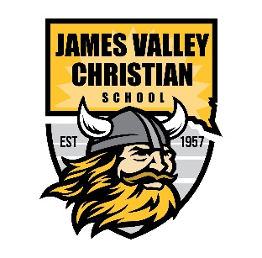

Financial Aid

There are two levels of tuition assistance available at James Valley Christian School.

1. **South Dakota Partners in Education (SDPE)**

SDPE was created because they believe “children learn in different ways and in different environments. SDPE wants to partner with parents so that parents have the opportunity to choose the school where their child will succeed.”

SDPE is a private, non-profit organization that provides scholarships to parents who meet specific eligibility requirements.

Please visit the application page to view eligibility requirements and complete the 3-step process. <https://sdpartnersinedu.org/families>

Do you have questions or need help completing the application? Please call us at 605-352-7737, and we would be happy to assist you with the application process.

Note: Those who qualify for SDPE scholarships are awarded scholarships until the funds are exhausted. Applications for the 2024-2025 school year open on February 1. We encourage you to apply as soon as possible.

1. **JVCS Scholarship Fund**

Those who have applied for the SDPE scholarship may also apply to the JVCS Scholarship Fund. JVCS will use your SDPE application and [Application For Enrollment Form](https://jvcs.org/home/applications-for-enrollment.html) to evaluate additional financial support. Funds in the JVCS Scholarship Fund are gifts from generous donors who believe in Christian education. Additional scholarships may be awarded based on the availability of funds from donors. Please indicate your interest in applying for the JVCS Scholarship fund by emailing [bookkeeper@jvcs.org](mailto:bookkeeper@jvcs.org)

**Note**: Combined financial aid from SDPE and the JVCS Scholarship fund can not exceed 50% of the standard billed tuition and fees.